**An Intelligent Automated face recognition**

1. Project idea in details:

( What is facial recognition?)

## A face analyzer is software that identifies or confirms a person's identity using their face.

## works by identifying and measuring facial features in an image. Facial recognition can identify human faces in images or videos.

## Biometric security systems use facial recognition to uniquely identify individuals during user onboarding or logins as well as strengthen user authentication activity.

## Mobile and personal devices also commonly use face analyzer technology for device security.

## (What are the benefits of facial recognition technology?)

#### **Efficient security**

## Facial recognition is a quick and efficient verification system. It is faster and more convenient compared to other biometric technologies like fingerprints or retina scans. There are also fewer touchpoints in facial recognition compared to entering passwords or PINs. It supports multifactor authentication for additional security verification.

#### **Improved accuracy**

Facial recognition is a more accurate way to identify individuals than simply using a mobile number, email address, mailing address, or IP address. For example, most exchange services, from stocks to cryptos, now rely on facial recognition to protect customers and their assets.

#### **Easier integration**

Face recognition technology is compatible and integrates easily with most security software. For example, smartphones with front-facing cameras have built-in support for facial recognition algorithms or software code.

## (How does facial recognition work?)

Facial recognition works in three steps: detection, analysis, and recognition:

### **Detection**

Detection is the process of finding a face in an image. Enabled by computer vision, facial recognition can detect and identify individual faces from an image containing one or many people's faces. It can detect facial data in both front and side face profiles.

#### **Computer vision**

#### Machines use [computer vision](https://aws.amazon.com/computer-vision/) to identify people, places, and things in images with accuracy at or above human levels and with much greater speed and efficiency. Using complex artificial intelligence (AI) technology, computer vision automates extraction, analysis, classification, and understanding of useful information from image data. The image data takes many forms, such as:

1. Single images
2. Video sequences
3. Views from multiple cameras
4. Three-dimensional data

### **Analysis**

The facial recognition system then analyzes the image of the face. It maps and reads face geometry and facial expressions. It identifies facial landmarks that are key to distinguishing a face from other objects. The facial recognition technology typically looks for:

1. Distance between the eyes
2. Distance from the forehead to the chin
3. Distance between the nose and mouth
4. Depth of the eye sockets
5. Shape of the cheekbones
6. Contour of the lips, ears, and chin

The system then converts the face recognition data into a string of numbers or points called a faceprint. Each person has a unique faceprint, similar to a fingerprint. The information used by facial recognition can also be used in reverse to digitally reconstruct a person's face.

### **Recognition**

Facial recognition can identify a person by comparing the faces in two or more images and assessing the likelihood of a face match. For example, it can verify that the face shown in a selfie taken by a mobile camera matches the face in an image of a government-issued ID like a driver's license or passport, as well as verify that the face shown in the selfie does not match a face in a collection of faces previously captured.

1. Main Functionalities:
2. System should identifying or verifying a person from digital image or video frame from a video source
3. being multiple methods in recognition systems work
4. work by comparing selected facial features from given image with faces within a database.
5. described as a Biometric Artificial Intelligence based application
6. System can uniquely identify a person by analysing patterns based on the person's facial textures and shape
7. Build a face recognition system
8. identifying a person from grayscale digital images using Artificial Neural Networks.
9. Build a face recognition system for identifying a person from grayscale digital images
10. using Artificial Random Forest& Dcision tree
11. Function for generate data set
12. Similar application in the market:

Many published works mentions numerous applications in which face recognition

Technology is already utilized including entry to secured high-risk spaces such as border crossings . on the other hand , there are other application areas in which face recognition

Has not yet been used . the potential application areas of face recognition technology can be outlined :

### **Luxand Face Recognition**

* This [app allows you to tap a detected face](https://www.emizentech.com/blog/best-face-swap-apps-online.html) and give it a name. Also, it helps recognize and memorize that face ahead. All you need to do is hold your device at your arm’s length and rotate it slowly at multiple views changing the location, and the app will recognize it. This app has the caliber to memorize various persons; if it doesn’t, you must repeat the process.

### **MojiPop – Art Metaverse**

* This app can create funny cartoon stickers of the clicked pictures. You just need to tap two times, and thousands of animated stickers and caricatures will be available to use for any situation or emotion for your clicked selfie. Also, you can share it with your friends and surprise them.

### **FaceApp: Face Editor**

* One of the top AI photo editing [mobile apps](https://www.emizentech.com/app-development-guide.html), FaceApp, lets you take a selfie and convert it into modeling portraits. It comes with every feature you need to craft the best edits ever, and that too is free. With just a single tap, you can also use its fantastic AI filters, effects, backgrounds, and more tools to craft a photorealistic edit

### **BioID Facial Recognition**

* The BioID app performs the best face recognition as a multi-factor user authenticator. Brands and developers can easily use this app to append biometric authentication to their mobile platforms with just a few code lines. On the other end, their end users can authorize the transaction or log in securely and seamlessly. So, this app saves your employees, users, and even yourself from photo attacks and prevents video-replay attacks.

### **AppLock – photo lock**

### Now you can protect your privacy with pattern, password, and fingerprint lock. This app supports around 45 languages and can lock WhatsApp, Facebook, Instagram, Messenger, Gallery, Contacts, SMS, and more. This way, you can guard your privacy and protect against unauthorized access.

### **Time Dynamo**

* A professional attendance management app, Time Dynamo, empowers businesses with real-time log-ins and log-outs. Also, it offers various automated solutions with just a few clicks. You can use this app to avail all the possibilities of time management meeting your varied business needs.

### **True Key™ by McAfee**

* Now, you can unlock the digital world quickly and safely. You don’t need to remember various passwords; you can easily log in to your websites, apps, and devices using this app. Moreover, it automatically fills and stores the password details and lets you enjoy access to your sites, apps, and devices.

### **Railer – Face Attendance**

* With the face recognition and mobile attendance management app, Railer helps in employee check-in, check-out quickly maintains time attendance, leave management, analytics and reporting, and much more.

### **LogMeIn**

* Now, you can get secure computer access anytime, anywhere from your Android device. Moreover, you can access your data, files, and apps and do the stuff you need to perform. So, you will get everything at your fingertips.

### **Blippar – The Augmented Reality browser**

* Using AI and AR technologies, Blippar assists you in witnessing, learning, and experiencing this digital world. You can scan and see what you discover. So, scanning is easy with Blippar, which recognizes everything you want, identifies it, and reveals its details.

1. Initial literature review of Academic publication:
2. Introduction

Institutional research (IR) comprises a set of activities that support institutional planning, policy development, and decision making within higher education institutions (HEIs). In recent years, the urge to achieve excellence in research has led HEIs to have greater awareness of their roles in the entire educational management process and to place more strategic emphasis on the development of assessment tools for monitoring and evaluating the research quality. In the USA and Japan, IR has been widely and successfully applied to evaluation, strategic planning, budget analysis, enrollment management, and research studies. Their studies focus on income analysis, research activities, and some issues reflecting strategic targets of HEIs. These studied issues might have some diversities from technical and vocational universities and colleges in Taiwan. Thus, Taiwanese technical and vocational universities need to discover their own IR issues for specific targets and constraints. Students, the indispensable participants in universities, their learning performance, and their attitudes towards these campuses should be seriously evaluated since they not only impact students’ motivation, but also affect teaching quality and shape the design and delivery of university courses. Specially, students’ early performance prediction is important to academic communities so that strategic intervention can be planned before students reach the final semester. If universities in general, and Taiwanese technical and vocational universities can, in particular, analyze students’ learning data to understand the important variables of learning effectiveness, they not only can predict the strength and weakness of students’ learning conditions, but can also propose preventive measures at the early stages. For students who may have outstanding academic performance, educational teams can invest resources to encourage students to strengthen their language, employment and research skills, help them find better opportunities, and set an example in order to help universities recruit more outstanding students. For students whose learning effectiveness is lagging behind, universities can provide additional remedial teaching and provide other measures to enhance schoolwork, such as providing teaching assistants and strengthening basic subjects and skills. In addition, HEIs need to continually increase the quality of teaching and the academic performance of their students. In practice, students of Taiwanese technical and vocational universities often suffer from relatively low academic performance and rather high drop-out rates due to their fairly poor financial situation. However, finance is not the only factor affecting students’ learning performance. According to the statistics of the drop-out rate in the 2019 academic year of the Ministry of Education of Taiwan government, the rate is 6.3% for general universities and 8.2% for technical colleges. In addition, there are 186,446 people who leave school each year, accounting for 15.3% of all tertiary students. Among them, the majority drop-out students leave schools after the first year. The biggest factor for leaving tertiary education, aside from lack of interest, is poor academic performance. Therefore, to build a prediction model for learning to avoid dropping out is extremely important. In recent years, machine learning algorithms, and artificial intelligence (AI) have been widely applied to predict students’ learning performance and to find the important features that have high impact on students’ academic performance. Machine learning techniques were employed in to examine the effect of co-curricular activities on a student’s academic performance. Tree-based models and artificial neural networks (ANN) were built in to analyze students’ academic performance in virtual learning. In the latest research, explainable artificial intelligence (AI) refers to methods, which can produce accurate and explainable models of AI algorithms. Thus, AI solution results can be understood by humans. Following this trend, this study will use machine learning algorithms including decision trees (DT) and random forests (RF) algorithms, which can generate explainable results, to predict freshmen’s academic performance. Except for DT and RF, multilayer perceptron (MLP) will be performed as our comparison base. The prediction of first-year student academic achievements has received substantial attention in educational practice and theory. Previous works used some variables, such as resilience, engagement, scores of quizzes and assignments, students’ academic self-concept, motivation, social relationships, and participation, to construct prediction models of first-year academic achievements. However, the information on these variables in the research can only be obtained during the course or in the progress of the semester. Some information also needs to be obtained through survey questionnaires and interviews. This is not enough to improve students’ learning performance in time, which is especially true for those students who are performing poorly due to economic factors. In Taiwanese vocational universities, the majority of students are economically disadvantaged. They often need to rely on government tuition, miscellaneous fee waivers, and student loans to register. In addition, they must work part-time every month to support themselves and their family’s living expenses. In addition to lack of interest, the biggest reason for dropping out is due to poor learning results. Therefore, the models established in published and the prediction results are often less timesensitive. A predictive model needs to be established before the semester begins to provide student counseling, financial assistance, and supplements. The annotation of teaching resources could be more accurate and more immediate. Therefore, this study attempts to use family background variables, including department, gender, address, admission status, Aboriginal status, child of new residents, family children ranking, oncampus accommodation, main source of living expenses, student loan, tuition waiver, parents’ average income, status, occupations, and education. These variables can be obtained before the start of the semester, in order to construct predictions before the freshmen students start to learn, and thus buy more time for student guidance or investing learning resources in technological and vocational education. In sum, this paper aims to build a prediction model that can be used to predict freshmen students’ learning performance based on decision trees and random forest algorithms. The sample was 2407 freshmen who enrolled in 12 departments of a university in Taiwan. From this constructed model, we can determine which students will succeed and which students indicate to be poor; the university is then able to offer them necessary assistance before they start their sophomore year. Based on experimental results, we can highlight some factors, which highly affect the first-year undergraduates’ learning performance.

1. Literature Review

2.1- The Learning Performance of First-Year Students Students’ learning performance plays a vital role in universities since it affects both individual and organizational performance; therefore, studies on factors and variables affecting students’ learning performance have been in existence for decades and have continuously attracted an increasing number of diverse researchers. In 1975, four factors were identified as causing poor students’ academic performance: (1) society, (2) school, (3) family, and (4) student. In contrast, general factors affecting successful learning performance. reported that the factors, such as gender, students’ ages, and students’ high school scores in mathematics, English, and economics affected university students’ scores and they also concluded that students with high scores in their high schools performed better in their university level. Additionally, studied the relationship between students’ matriculation exam scores and their academic performance and found that a student’s admission scores positively affected their undergraduate's performance. The idea of applying data mining in the educational system attracted since data mining can show discovered knowledge to educators and academic teams, and show recommendations to students. Moreover, used ANN for university educational systems applied ANN in a narrower field of academic performance prediction in university. Particularly, Oladokun et al.utilized an ANN model to predict students’ academic performance based on factors, such as ordinary level subjects’ scores and subjects’ combination, matriculation exam scores, age on admission, parental background, types and location of secondary schools attended, and gender. Students’ learning performance was predicted based on their average point scores (APS) of Grades 12, on high school scores, and on cumulative grade point average (CGPA) in fundamental subjects. The predictors of first-year student success have received much attention in educational practice and theory. Consequently, many researchers have paid attention to this issue. For example, Ayala and Manzano investigated whether or not a relationship between the dimensions of resilience and engagement, and the academic performance of first-year university students. Baners et al. (2019) aimed to identify at-risk students by building a predictive model using students’ grades. Their model can predict at-risk students during the semester on a firstyear undergraduate course in computer science. Neumann et al. focused on first year international students in undergraduate business programs at an English-medium university in Canada. They found there to be a positive relationship between students’ academic self-concept and subsequent academic achievement. In the work of Anderton, he indicated gender and the Australian Tertiary Admissions Rank as significant predictors of academic performance. After surveying 80 published articles, Zanden et al. found that some predictors contributed to multiple domains of success, including students’ previous academic performance, study skills, motivation, social relationships, and participation in first-year programs. We can establish from these published works the variables used, such as resilience, engagement, scores of quizzes and assignments, students’ academic self-concept, motivation, social relationships, and participation to build prediction models. However, the information on these variables used in the literature can only be obtained during the course or in the progress of the semester. As well, some information needs to be obtained through questionnaires and interviews. This shortens the time for universities to take remedial measures, especially for some students of poor learning performance, caused by economic factors. In practice, obtaining this information and then making predictions based is too slow to prevent students from dropping out due to poor academic performance. Therefore, this study attempts to use family background variables, including department, gender, address, admission status, Aboriginal status, child of new residents, family children ranking, oncampus accommodation, main source of living expenses, student loan, tuition waiver, parent’s average income, status, occupations, and education. These variables can be obtained before the start of the semester, allowing to make predictions before the freshmen students start to learn, and providing more time for student guidance or investing in learning resources

1. Decision trees

Decision trees (DT) are widely applied for prediction and classification in domain of machine learning. DT have the advantages of simple use, easy understanding, high accuracy, and high prediction ability. In recent years, decision trees have been successfully applied in education areas. For example, Wang et al. proposed a higher educational scholarship evaluation model based on a C4.5 decision tree, while Hamoud et al. used DT to predict and analyze student behaviors. Their results indicated that students’ health, social activities, interpersonal relationships, and academic performance affected learning performance. Furthermore, authors in used the DT method to conduct research on students’ employment wisdom courses in order to provide solutions for training professionals and employment courses, and to solve the contradiction between training plans and enterprise needs. A semi-automated assessment model was built by using DT in. There are a variety of DT algorithms, such as ID3, C4.5, C5.0 (a commercial version of C4.5), and CART (classification and regression tree). Among them, C4.5 and CART algorithms are the most popular and have many useful applications. Compared with other classification methods, such as ANN and support vector machines, the decision tree can extract readable knowledge rules, which is helpful for university-side decision-making reference. Therefore, this study will use decision trees algorithms, including C5.0 and CART, to build DT prediction models.

1. Random Forest

Random forests (RF) are regarded as an effective method in machine learning since RF can solve the problems of over-training, which decision trees may face. RF operates classification, regression, and other tasks by constructing multiple decision trees during training. The calculation method is to evaluate multiple independent DT and determine the result through their voting results. When each node in DT is split using the best among the attributes, “each node in RF is split using the best among the subset of predictors randomly chosen at the node”. RF has been widely applied to IR in universities. For example, in the work of, they used RF to predict if a student would obtain an undergraduate degree or not using the learning performance of the first two semesters of courses completed in Canada. Ghosh and Janan utilized 24 variables, including creating good notes, group study, adaptation to university, and selfconfidence, which were obtained from a questionnaire survey. RF was then employed to predict the first-year student performance of a university in Bangladesh. From the above literature, we can establish that RF has been successfully applied to predict students’ learning performance. Therefore, this study also applied RF as one of the candidate algorithms to predict the learning performance and to identify features, which importantly affect first-year students learning performance.

1. dataset:

Introduction:

. In this study, face recognition was performed using the face images in the Olivetti

dataset. The steps for face recognition are as follows:

* Principal components of face images were obtained by PCA.
* Adequate number of principal components determined
* According to three different classification models, accuracy score obtained.
* According to three different classification models, cross-validation accuracy score were obtained.
* Parameter optimization of the best model has been made.

the distance of the determined feature points and the angles between them, the shape of the facial features or the variables containing the regional features are obtained from the face image are used in face recognition. Analytical methods examine the face images in two different ways according to the pattern and geometrical properties. In these methods, the face image is represented by smaller size data, so the big data size problem that increases the computation cost in face recognition is solved.

Take images of the face at different times ,varying lighting facial expression and facial details

All face images have black background

Size of each image is 64x64

Image pixel values were scaled to [0, 1] interval

**Machine Learning Model for Face Recognition**

Machine learning models can work on vectors. Since the image data is in the matrix form, it must be converted to a vector.

**Split data and target into Random train and test Subsets**

The data set contains 10 face images for each subject. Of the face images, 70 percent will be used for training, 30 percent for testing. Uses stratify feature to have equal number of training and test images for each subject. Thus, there will be 7 training images and 3 test images for each subject. You can play with training and test rates.

**Principle Component Analysis**

Machine learning methods are divided into two: supervised learning and unsupervised learning. In supervised learning, the data set is divided into two main parts: 'data' and 'output'. The data holds the values of the sample in the data set, while the 'output' holds the class (for classification) or the target value (for regression). In unsupervised learning, the data set consists of only the data section.

Non-supervised learning is generally divided into two: data transformation and clustering. In this study, the transformation of the data will be carried out using unsupervised learning. Unsupervised transformation methods allow for easier interpretation of data by computers and people.

The most common unsupervised transformation applications is to reduce data size. In the size reduction process, the dimension of the data reduced.

Principle Component Analysis (PCA) is a method that allows data to be represented in a lesser size. According to this method, the data is transformed to new components and the size of the data is reduced by selecting the most important components.

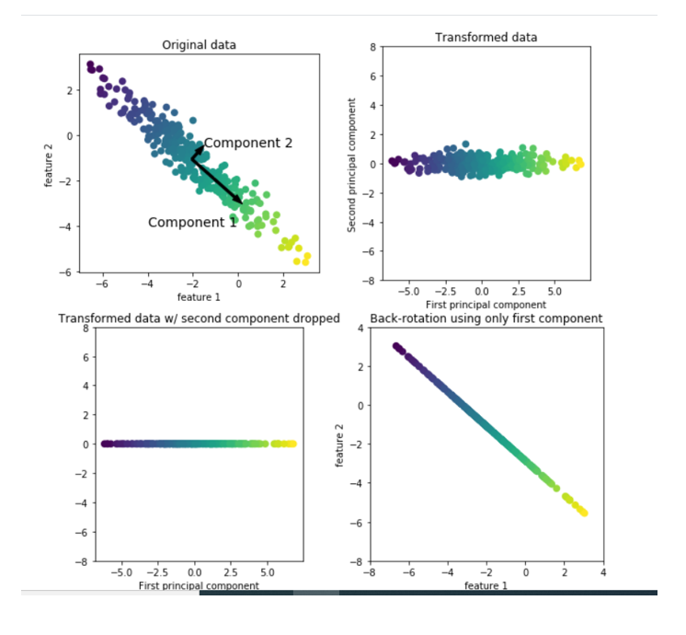

The above illustration shows a simple example on a synthetic two-dimensional data set. The first drawing shows the original data points colored to distinguish points. The algorithm first proceeds by finding the direction of the maximum variance labeled "Component 1". This refers to the direction in which most of the data is associated, or in other words, the properties that are most related to each other.

Then, when the algorithm is orthogonal (at right angle), it finds the direction that contains the most information in the first direction. There are only one possible orientation in two dimensions at a right angle, but there will be many orthogonal directions (infinite) in high dimensional spaces.

**PCA Projection of Defined Number of Target**

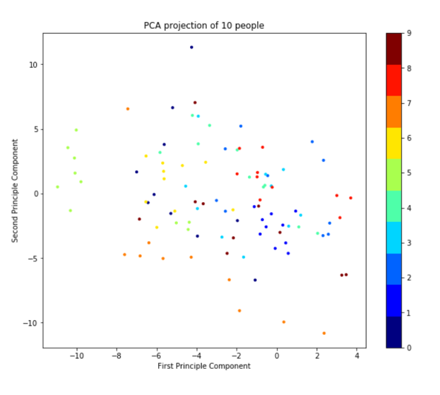

**Finding Optimum Number of Principle Component**

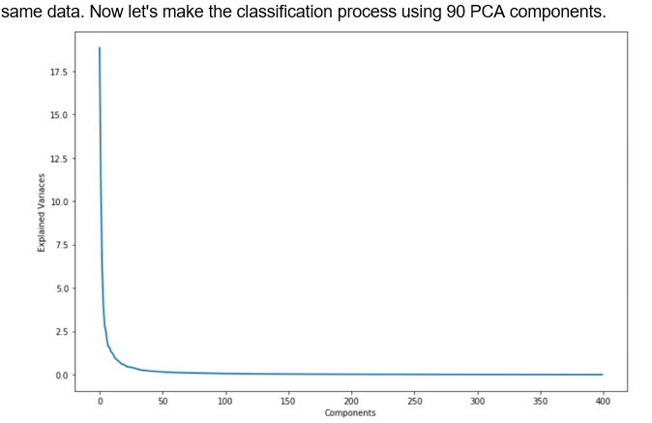

In the figure above, it can be seen that 90 and more PCA components represent the same data. Now let's make the classification process using 90 PCA components.

**Show Average Face**

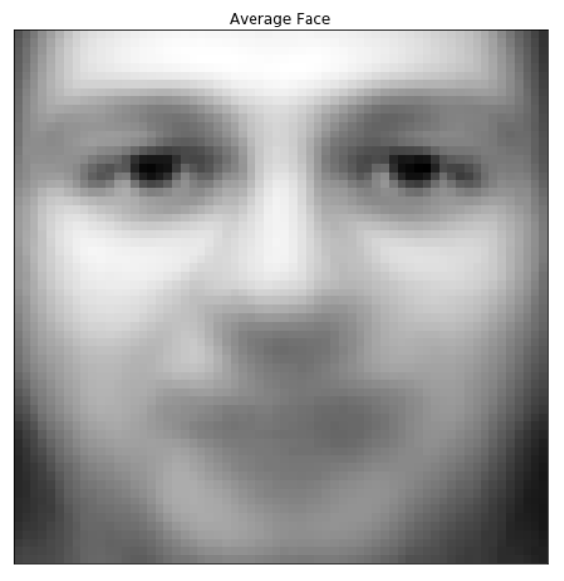

**Show Eigen Faces**

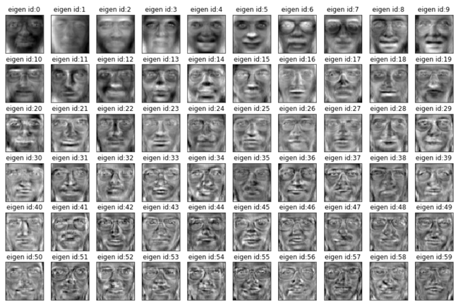

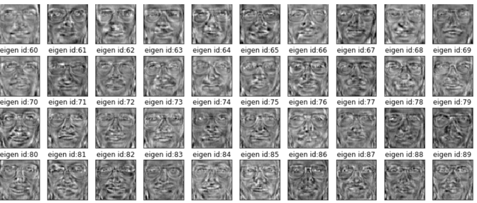

**Classification Results**

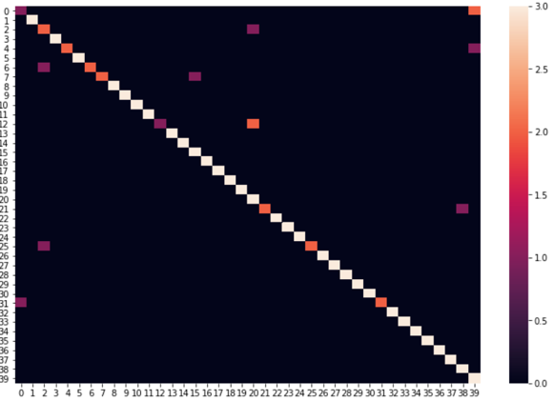

**Precision-Recall-ROC Curves**

Precision-recall curves are for binary classification. In Olivetti dataset, there are 40 distinct classes. Dont worry, sklearn allows us to illustrate the precision-recall in multi-label settings

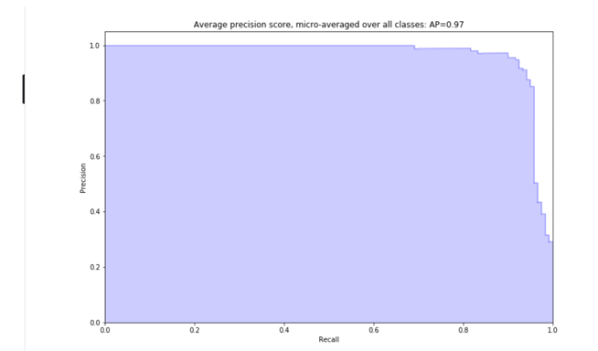

**Linear Discriminant Analysis İle Boyut Azaltma**

Classification Results:

precision recall f1-score support

0 0.50 0.33 0.40 3

1 1.00 1.00 1.00 3

2 0.60 1.00 0.75 3

3 1.00 1.00 1.00 3

4 1.00 1.00 1.00 3

5 1.00 1.00 1.00 3

6 1.00 1.00 1.00 3

7 1.00 0.67 0.80 3

8 0.75 1.00 0.86 3

9 1.00 1.00 1.00 3

10 1.00 1.00 1.00 3

11 1.00 1.00 1.00 3

12 1.00 0.67 0.80 3

13 1.00 1.00 1.00 3

14 1.00 1.00 1.00 3

15 1.00 1.00 1.00 3

16 1.00 1.00 1.00 3

17 1.00 1.00 1.00 3

18 1.00 1.00 1.00 3

19 1.00 1.00 1.00 3

20 1.00 1.00 1.00 3

21 1.00 0.67 0.80 3

22 1.00 1.00 1.00 3

23 0.75 1.00 0.86 3

24 1.00 1.00 1.00 3

25 1.00 0.67 0.80 3

26 1.00 0.67 0.80 3

27 1.00 1.00 1.00 3

28 1.00 1.00 1.00 3

29 1.00 1.00 1.00 3

30 1.00 1.00 1.00 3

31 1.00 1.00 1.00 3

32 1.00 1.00 1.00 3

33 1.00 1.00 1.00 3

34 1.00 1.00 1.00 3

35 1.00 1.00 1.00 3

36 1.00 1.00 1.00 3

37 1.00 1.00 1.00 3

38 0.75 1.00 0.86 3

39 0.75 1.00 0.86 3

micro avg 0.94 0.94 0.94 120

macro avg 0.95 0.94 0.94 120

weighted avg 0.95 0.94 0.94 120

1. details of Algorithms approaches :

Introduction:

The facial recognition plays a role in computerized system, and its aim is in recognizing individuals by using computerized system. Pattern recognition, machine learning, artificial recognition represents emerging approaches in training of smart mobile computers for human recognition. This is very complex issues; therefore, it consists of various different features. In was proposed implementation of PCA for mobile recognition. This paper we discuss the novel results, whose purpose for the future study and exploration is to perform on mobile machine with much higher rate of accuracy. In here, we are presenting the result of random forest (RF) compared with Support Vector Machine (SVM). Human brains are highly capable of recognizing humans instantly. Emphasize of this research is in training the machine system to be capable to learn and to recognize with the ability that will be closest in accuracy as human. Today, there exists higher need for artificial recognition using face, more than just a finger prints or other biometric features. In general face recognition consists of feature vector matching as described in Principle Component Analysis. In this study we have used 40 human faces and for each face we used 20 different facial images for each person, which in total are 800 images of 205x274 sizes. The purpose of this research is to bring well designed approach for face recognition; therefore, it can be incorporated and tested on real time application for mobile security. In studies conducted before, the images recognition has been done by applying the statistical model of PCA with feature vector extraction or SVM feature vector extraction. The methodology of this research is: images were read from database, 3D color image RGB are read from database then is performed skin color detection, then RGB to gray, histogram, SVM/RF, classify and authentication. The results obtain by accomplishing these steps for SVM 97.94% and Random Forest 97, 17%.

**This paper is organized as follows:**

* Introduction
* 2. Random Forest and Support Vector Machines Background
* 2.1. Random Forest
* 2.2. Support Vector Machines
* 2.3. Linear Support Vector Machines
* 3. Discussion
* 3.1. Methodology
* 4. Result and Discussion
* 4.1. Performance Evaluation
* 4.2. Experimental Results
* 4.3. Experiment 1, 2, and 3 SVM with Puk Kernel and Linear Kernel
* 4.4.Random Forest
* 5. Conclusion

This paper briefs on Random Forest and Support Vector Machines and in Section 2, it will present the performance of face recognition using these two approaches

Random Forest and Support Vector Machines Background:

**Random Forest**

Each learning method includes some methods of randomization. Such aim is to choose the best option at every step. Very famous is random forest. Random forest learns built randomized decision tree. For each iteration the algorithm often produces excellent predictors. Random Forest basic idea is to find the average value of noise. Very complex interaction trees can capture. Complex input space can be computed into simpler space and it’s the aim of decision tree. Random forests are collection of decision trees. In has shown that the collection of random forest, decision trees trained randomly. Therefore, available data reduces the over fitting in comparison. Therefore, RF methodology is extension of bagging classification tree. It is a parallel learning process. It achieves a high accuracy and has fast training phase. The advantages of random forest are:

• Straightforward learning

• Local representation

• Classification with occlusion

• Parallelization

• Fast Training Time

It uses random selection methods, so it can perform a better, especially when there are many redundant features discrimination [1,9]. The method that describes random forest [1] follows: For b = 1, …, B, sample n, observations with replacement from L [1,8]. It refers [1]: 1. Node t, randomly sample m of the p independent variables 2. of the k=1, …, m sampled variable; among all splits of variable kth, find the best split. 3. In s*, choose the best split from among k = 1, …, m; find the best split for splitting node t; Jt variable is defined cut point s* c that is used for splitting node t. 4. At this node, split the data by sending the i = 1, …, n; observation with ij s* x c to the left descending node and all observation ij s* x c to the right descendant. 5. Repeat steps 1 to 4 on all descendant nodes for growing a maximally sized tree, Tb.

**Support Vector Machines**

A Support Vector Machine SVM performs classification by constructing an N – dimensional hyperplane that optimally separates the data into two categories. SVM models are related to neural

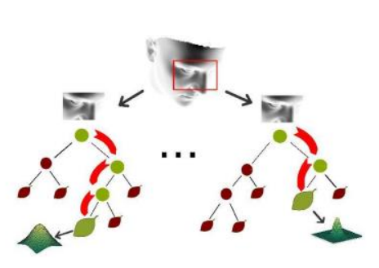

Fig.1. Example of regression forest for facial pose estimation networks. In fact, a svm model using a sigmoid kernel function that is equivalent to a two–layer perceptron neural network. The classical neural networks are very similar to model of Support Vector Machines (SVM). With usage of kernel, SVM’s are alternative training methods. Those methods are for polynomial, radial basis function and multi – layer perceptron classifier, where the weights of networks are found and defined in problem QP of quadratic programming problem with linear constrains. Sloping a non – convex and unconstrained minimization problem as what is it standard in neural network training. We are faced with many various descriptions in literatures that refer to the subject of Support Vector Machine. Sometimes we will find a predictor variable that is called an attribute, and transformed attribute that is used to define the hyperplane called a feature. The most suitable representation is known as feature selection.

Discussion

**Methodology**

In different research methodologies researcher for face recognition were using altered approaches [2]. They have had used different statistical methods as: PCA, LDA, SVM, K-NN, etc. [2]. They have been used edge detection methods, different algorithm approaches, comparing image to image directly. The aim of this research is to adapt to real time face recognition system. Moreover, we are presetting the best solution that will be implemented and incorporate in further study for mobile computer system. In [3] were dealing with detection and recognition of human faces using the random forest. The approach they were using is object / face detection, segmentation, feature extraction random forest and recognition. In [14] were performed SVM feature extractions for face recognition. Moreover, in [6,15] was performed PCA for face recognition. For this study images were acquired via mobile phone, since the initial study was intended to develop the reliable mobile system with the face recognition application. The resolution of mobile phone camera is 5 px. In Fig 4 is represented the sample of data sets. It is the International Burch University face image data set acquired for the research which takes implementation in facial recognition. The structure of the approach applied for facial recognition is presented in Figure 3

The following steps were:

• Read image

* ANN

• Skin Color Detection

• RGB to Gray

• Histogram

• SVM, RF

• Classify

• Authentication

The images were read into machine from database. The database consists of images in file system. Dataset consist of images with various poses. The poses which were taken into testing were: pose, presence of structural components, facial expression, occlusion, image orientation, image condition [16]. After considering all those images, we have performed Skin Color Detection

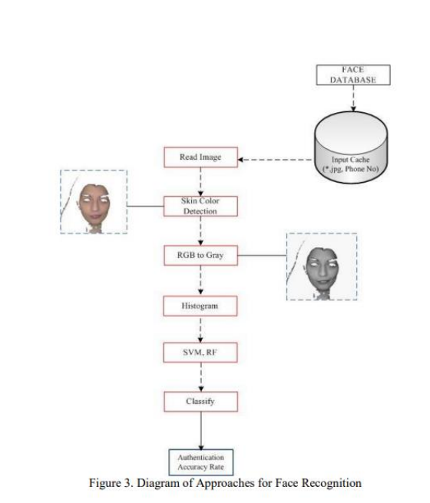

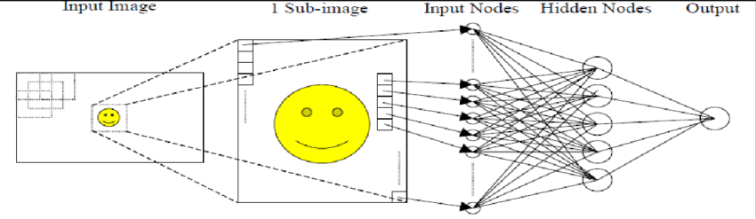

# ANN Testing for the Face Recognition System VI. EXPERIMENTAL RESULTS A MathLab was used to write the simulation program of training/testing of each one of the Four models (FFBPNN, CFBPNN, FitNet and PatternNet). The architecture of each model consists of 7 layers: input; 5 hidden layers each with 15 units; and output layer. The training data includes 350 (92×112) face images for 35 persons each with 10 samples were selected from Oral face database (Olivetti Research Laboratory) [22]. Here, we used the Mean Square Error (MSE), peak signal to noise ratio (PSNR) and recognition rate (RR) to evaluate the performance of ANN model for face recognition system.

Results and Discussion

**Performance Evaluation**

For performing the analysis based on image dataset of face poses is very interesting in predicting the people. Very different techniques can be applied. We have compared two methods: Random Forest and SVM [10,20]. For performing testing, we have dataset consisting of face images, training data for training classifier and test data for testing used for evaluation of final methods.

## Experimental Results

## The results presented in this study have demonstrated that SVM recognition rate is improved by extracting feature vectors from face images and using the histogram, where accuracy for RF has improved. In order to perform all calculations data is divided into training and test phase. We performed SVM Puk kernel, SVM Linear kernel with different number of k folds and Random Forest. The k number was 10 and 20 used for SVM linear kernel. This testing was done by using Weka 3.6 on desktop computer with 2 GB RAM and 3 GHz. In this study we have evaluated the face recognition for random forest and support vector machine. We applied first skin color detection, then RBG to Gray, after we have performed SVM and RF and we added some classifier. From face images we have extracted feature vector and histogram values. In this research in IBU face database images we have used 20 poses for each 40 people. Images were in JPEG format 205x274 pixel sizes. Dataset consisted of males and females.

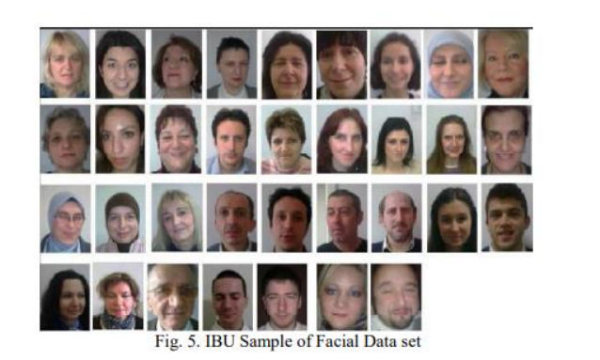

**Experiment 4: Random Forest**

The proposed Random Forest methods shows an improvement in facial recognition where further such methodology will incorporate with application model for human recognition application. Random forest performs with 97.17% accuracy, with 2.82% incorrectly classified instance. During the testing random forest constructed 30 trees, each constructed while considering 9 random features. Random forest constructed 30 trees considering 9 random features. The results are shown in Table 1 – 2. and Figure 7. For evaluation of random forest, the number of cross validation folds k = 10. F - Measure of random forest is 97 %, 0,972 respectively. The results of performing the random forest by using skin color detection and histogram has shown substantial improvements from the results of performing the detection and recognition of human faces in [7]. The ROC area (AUC=0,998) and is higher than in SVM. Based on the evaluation of data and study of presented work of face classification problems we can highlight the following:

• The performance of histogram values of face images performed on SVM linear kernel performs well accuracy.

• For training the SVM the appropriate classifier C were selected. And the optimal values of C where results perform better is C=100.

• We can see that random forest tree performs nearly good as SVM linear kernel

• Beside all the above mentioned such model incorporated with real time face recognition system for expert system may be improved with such higher accurate results via incising the versatile number of parameters.

1. Block diagram :

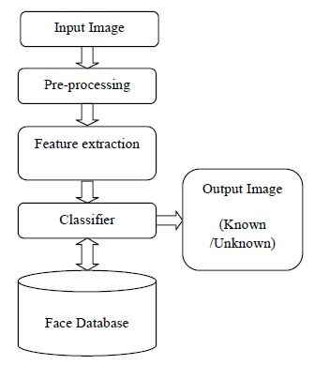

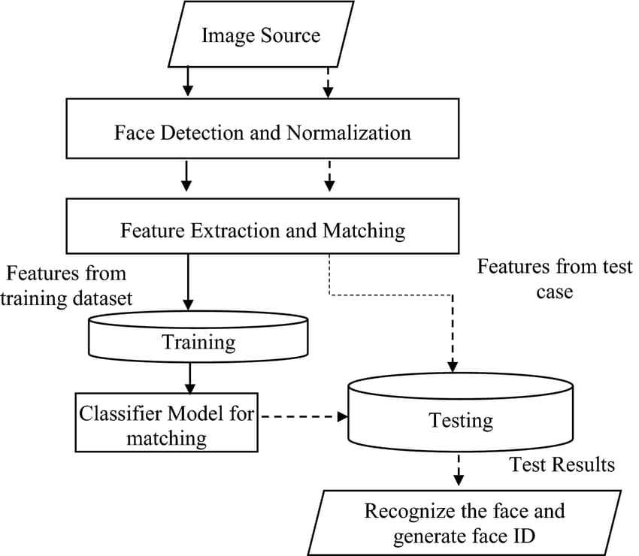

1. flowchart :

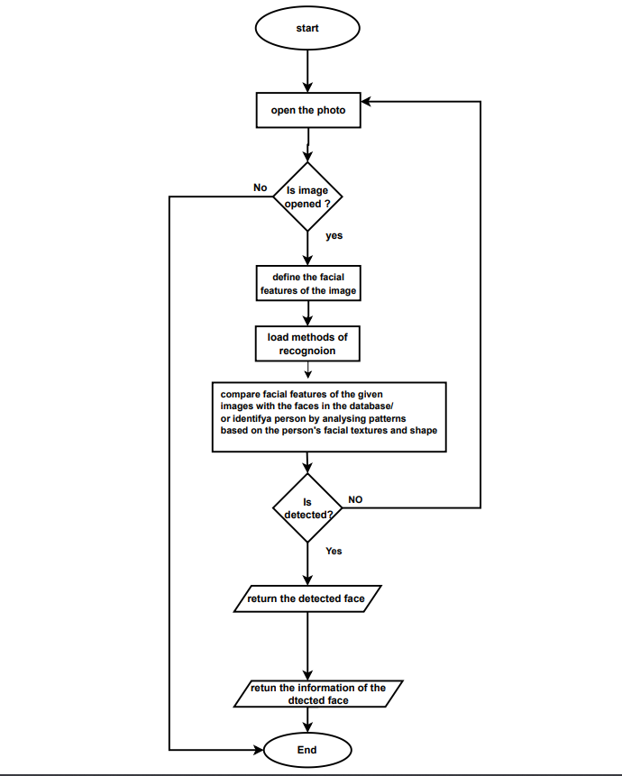

1. use case :

